**Practical No: 1**

Introduction and Contribution to Wikipedia

1. Description about Wikipedia and its features

**Wikipedia** is a free, multilingual open-collaborative online encyclopedia created and maintained by a community of volunteer editors using a wiki-based editing system. It is one of the 15 most popular websites as ranked by Alexa, as of January 2021 and *The Economist* newspaper placed it as the "13th-most-visited place on the web". Featuring no advertisements, it is hosted by the Wikimedia Foundation, an American non-profit organization funded primarily through donations.

Wikipedia was launched on January 15, 2001, by Jimmy Wales and Larry Sanger. Sanger coined its name as a portmanteau of "wiki" and "encyclopedia". It was initially an English-language encyclopedia, but versions in other languages were quickly developed. With 6.2 million articles, the English Wikipedia is the largest of the 317 Wikipedia encyclopedias. Overall, Wikipedia comprises more than 55 million articles, attracting 1.7 billion unique visitors per month.

**Basic features of a Wikipedia**

* Create a page. To contribute to a **Wikipedia**, you'll start by creating a page.
* Edit a page. Published pages can be edited by anyone that reads them.
* Link between pages. Linking between **Wikipedia** pages makes it easier for readers to find secondary materials they may need, especially as your **Wikipedia** grows.

1. Creating Account on Wikipedia

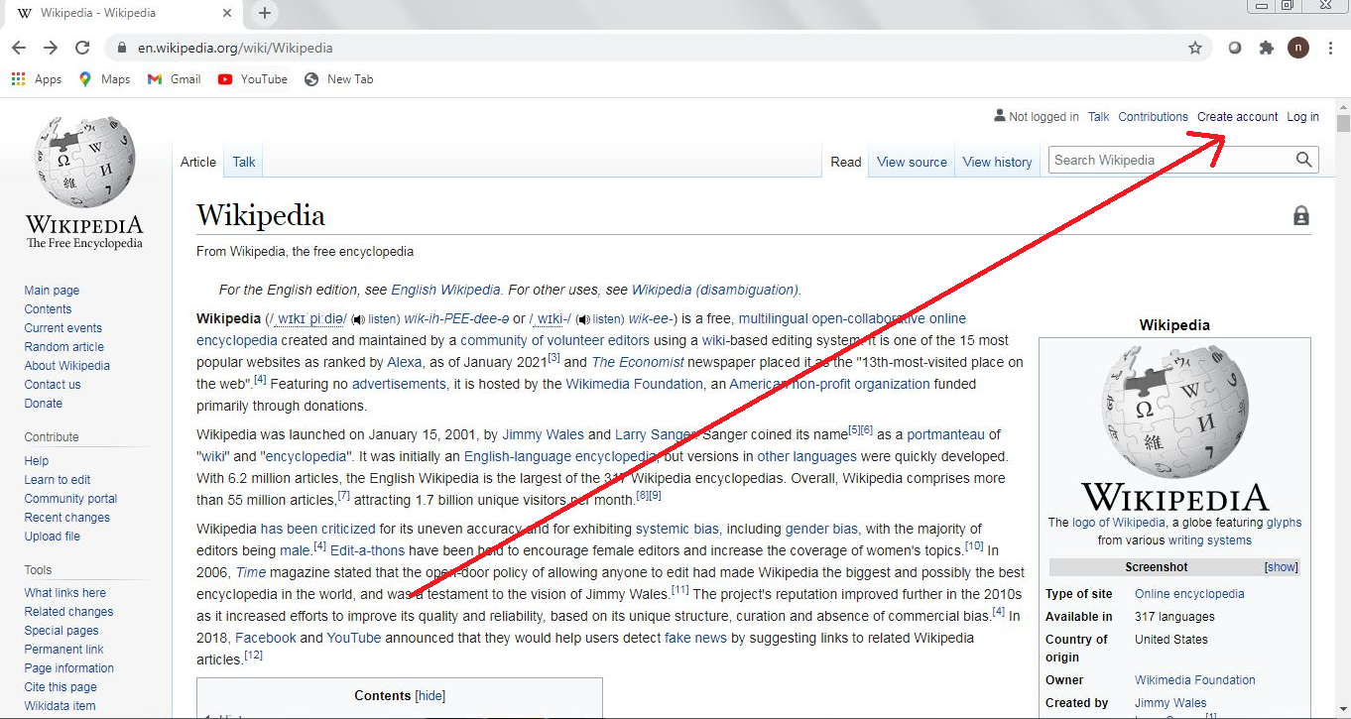

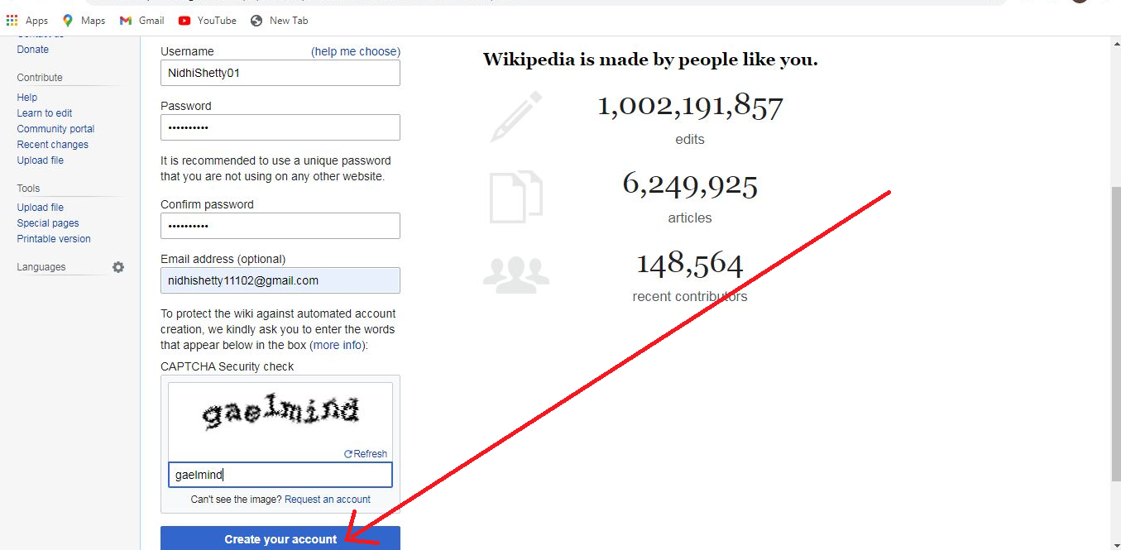

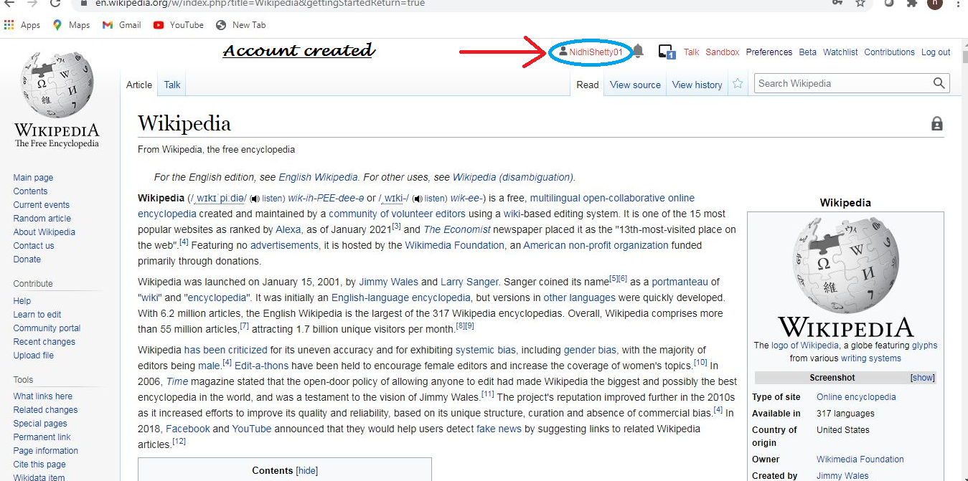

1. Creating your page on Wikipedia

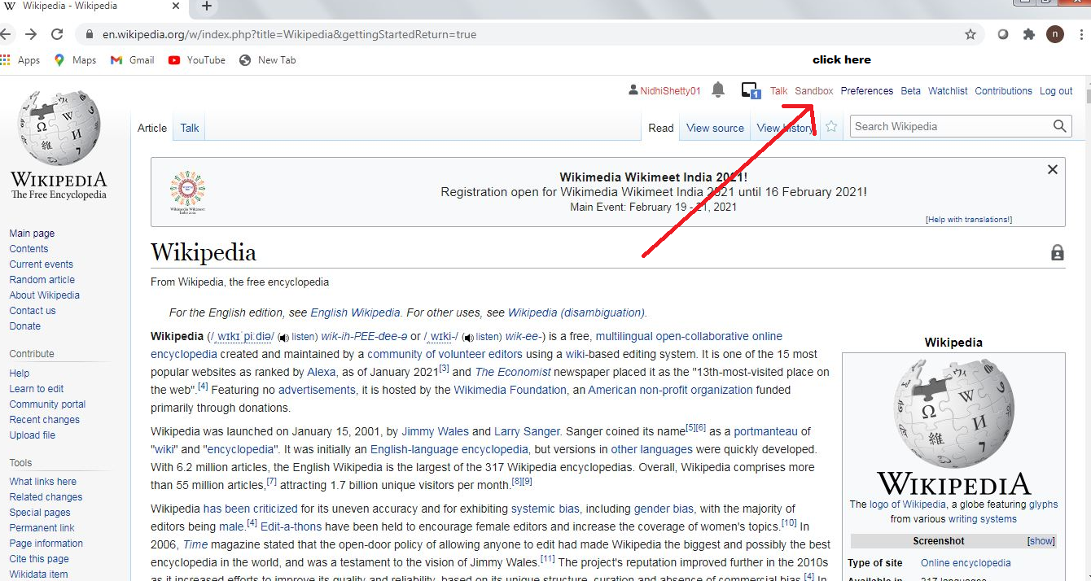

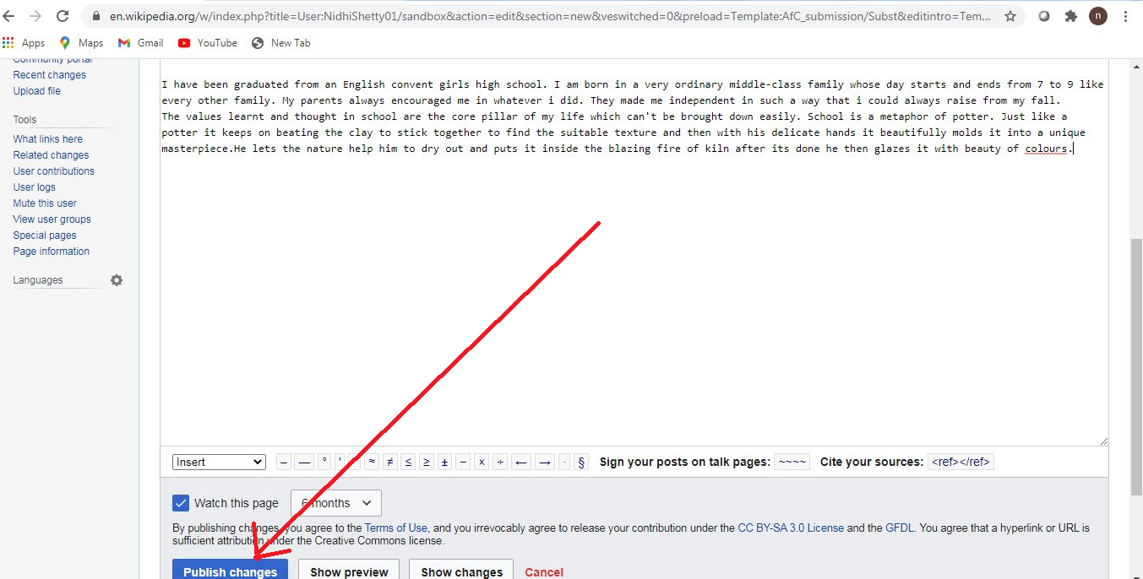

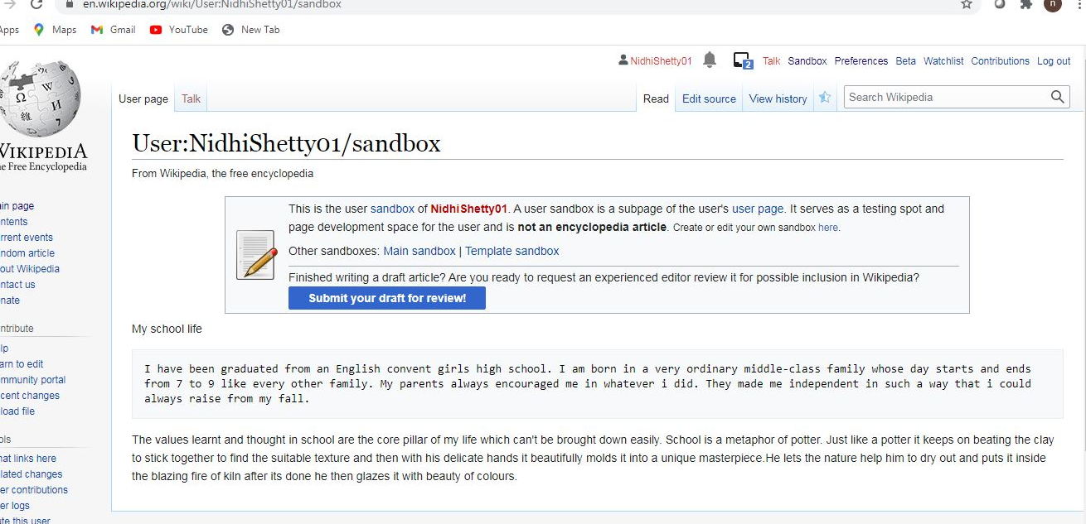

1. Editing your page on Wikipedia

